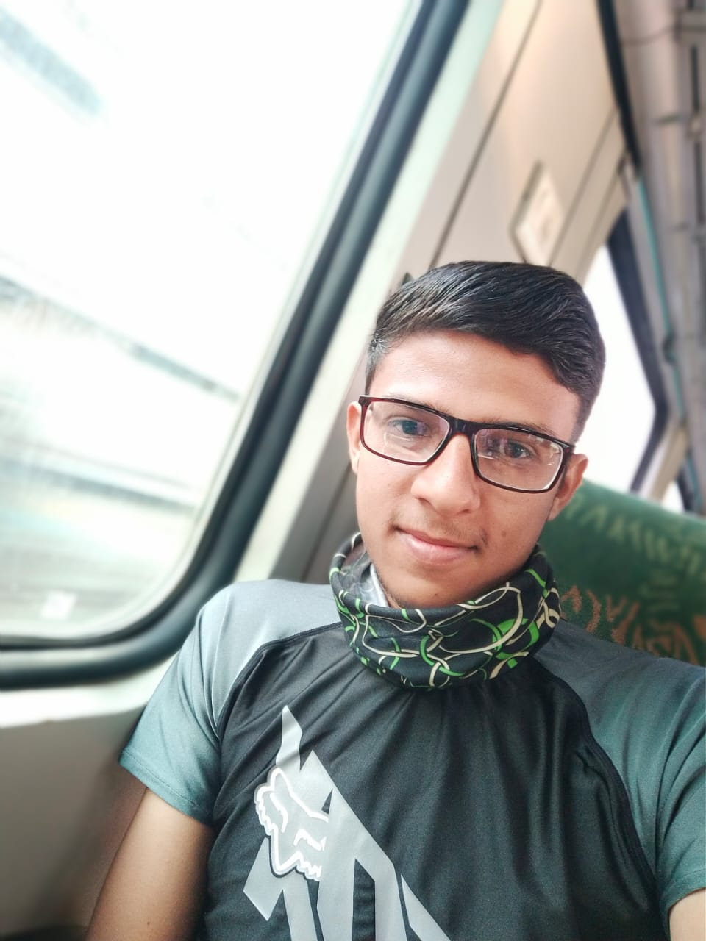

Game: 8 ball pool

Nasir Patel 4 wins out 8 Podium Finishes

Amount Won: 2800 IGL Coins

Game: PUBG Mobile

Utkarsh AKA Utkarshut

6 wins out 12 Podium Finishes

Amount won: 6500 IGL Coins

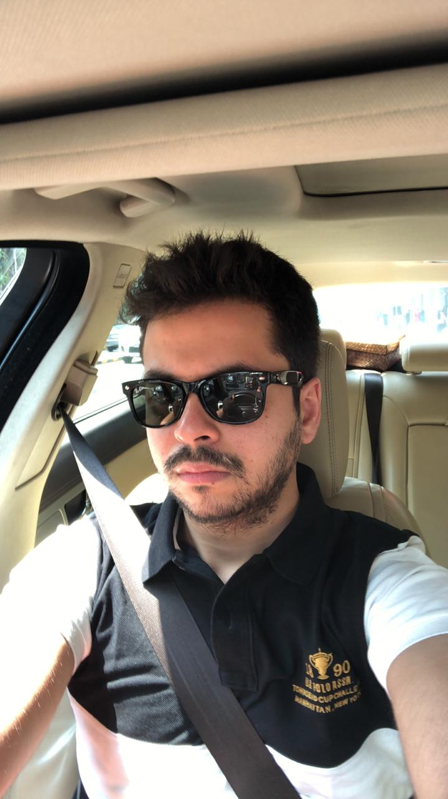

Game: Fortnite

Varun AKA Deathwish1104

2 wins out 3 Podium finishes. Amount won: 1300 IGL Coins



Game: Ludo King

Gappu AKA Slayer007

5 wins out 8 Podium Finishes

Amount won: 3150 IGL Coins

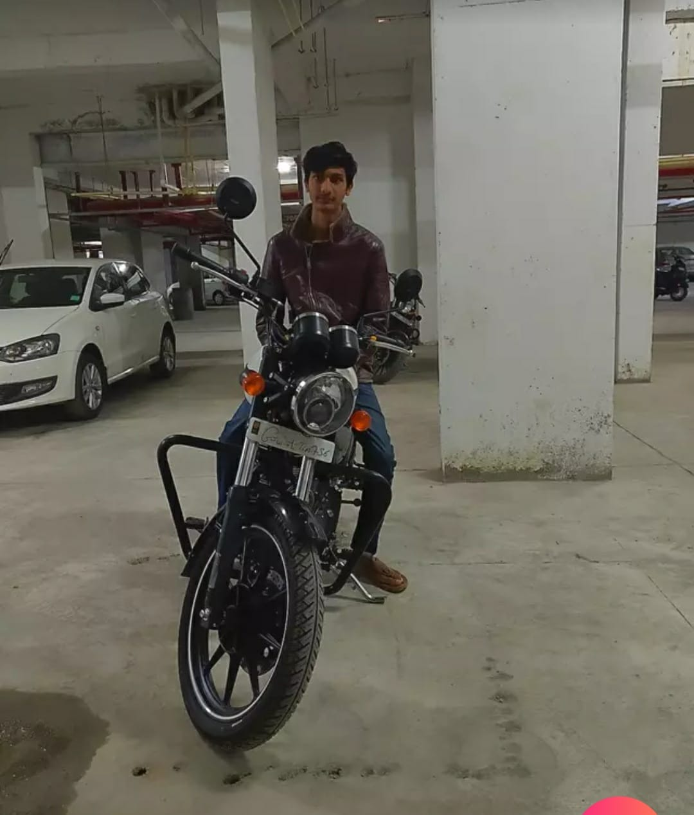Game: Call of Duty Mobile: Solo Multiplayer

Dhrumil AKA 2NUB4U

7 wins out of 8 Podium Finishes

Amount Won: 6500 IGL Coins

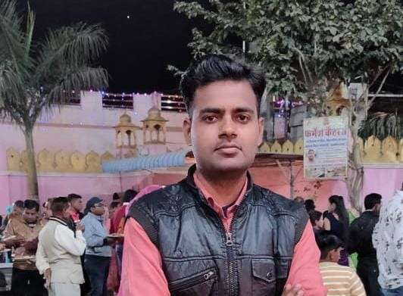

Game: Call of Duty Mobile: Battle Royale

Ashish AKA BeastSentry

3 wins out of 5 Podium finishes

Amount won: 2000 IGL Coins